Project Description
An InBody scan is a rapid, non-invasive body composition analysis that provides a comprehensive breakdown of your weight by measuring your muscle mass, fat tissue, and water levels. Unlike a standard bathroom scale that only shows total pounds, this technology uses Bioelectrical Impedance Analysis (BIA) to look beneath the surface and assess your overall metabolic health and physical fitness. Inbody scan’s are avialble at Select Gyms free of cost . If your gym has it, use it!!
Goal of project is to create AI powered StreamLit App to analyze Inbody scan results and provide comprehensive body composition overview which goes much beyond numbers. App analyzes Inbody scan results and provides details on what’s working, what’s not working, areas for improvement, key metric trends. Results are provided based on sample data provided as CSV.
UI Design
Streamlit App runs as local web application. Its not deployed. User inputs are Age, Gender, Weight, Height and Inbody scan results as a csv file. Sample csv is attached.
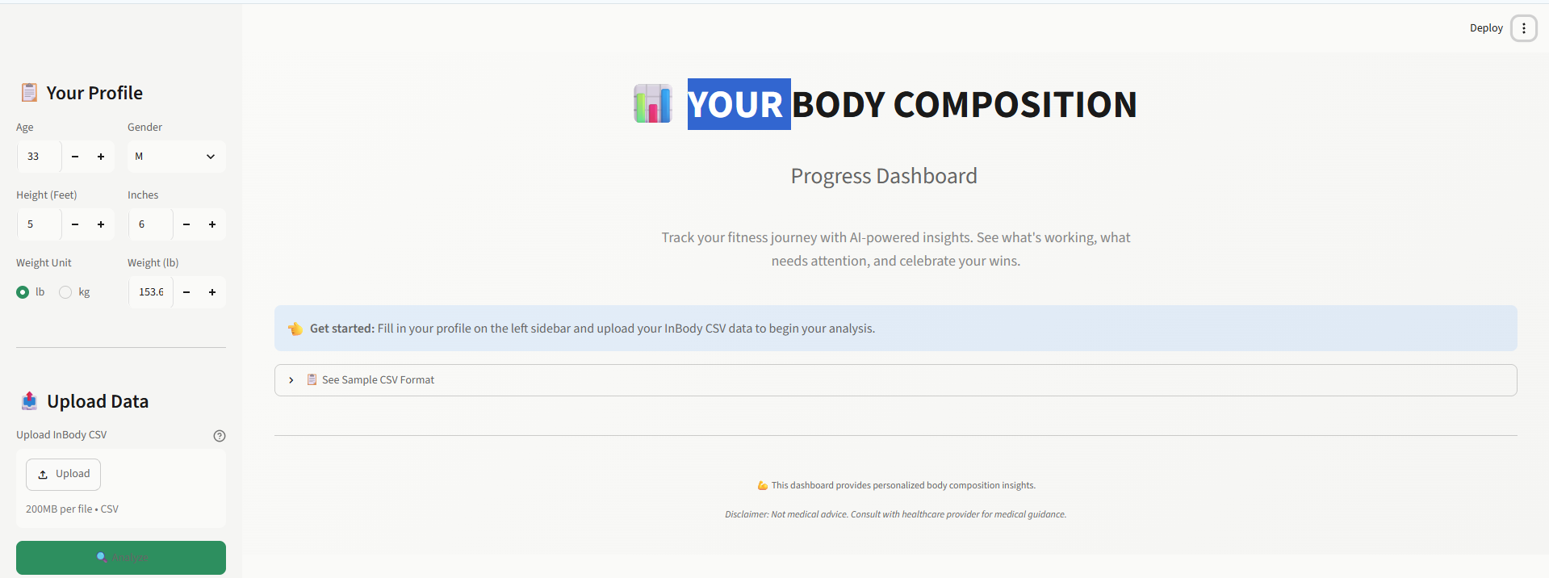
App provides results across 4 tabs once “Analyze” button is clicked
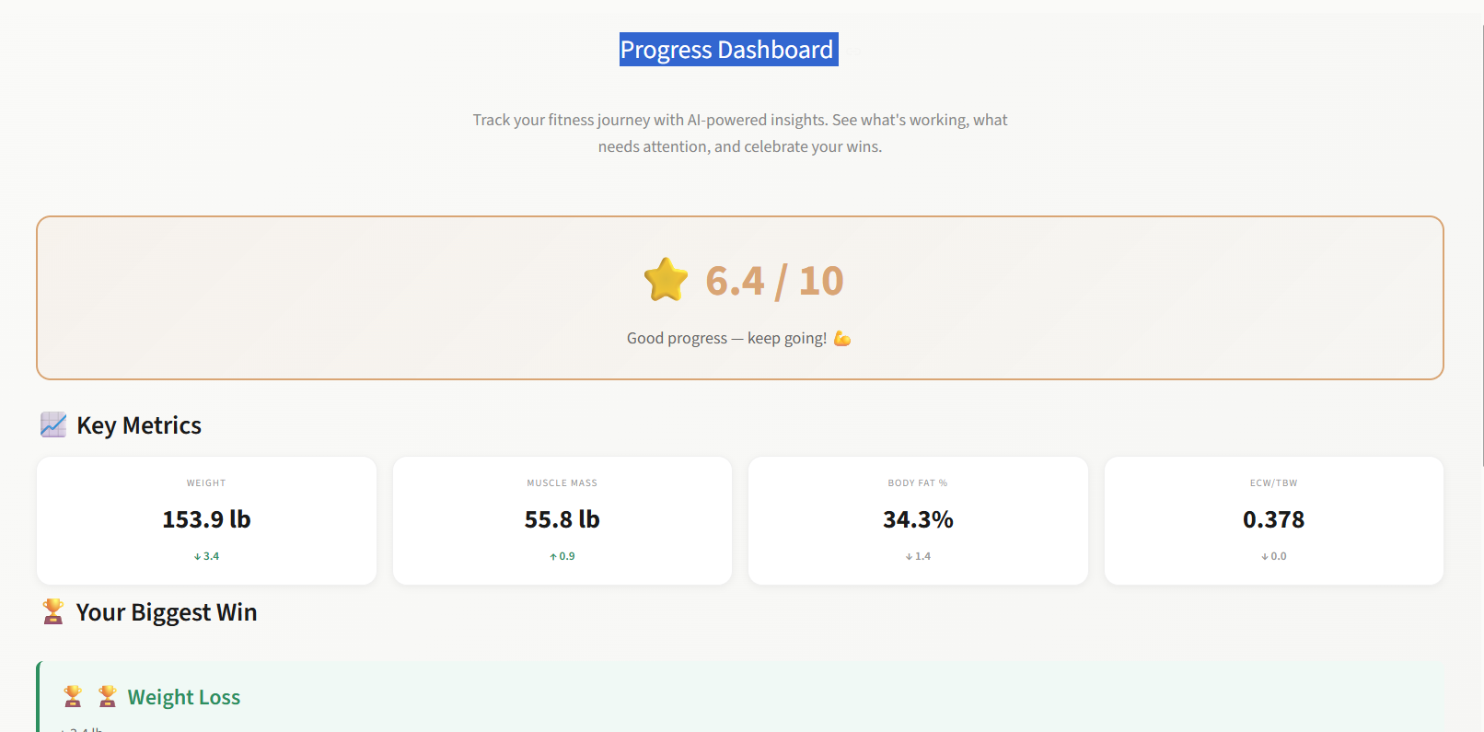

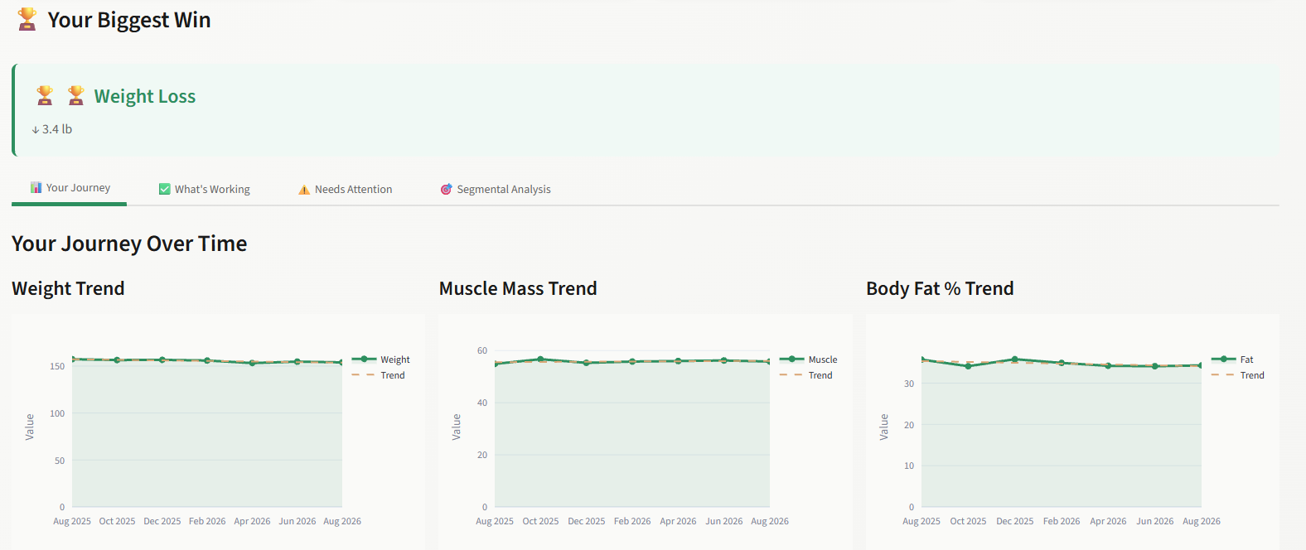

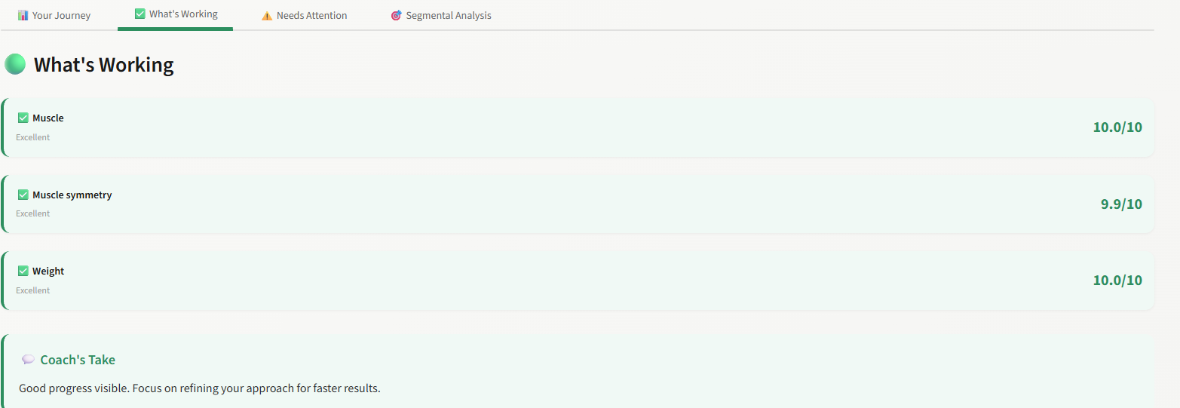
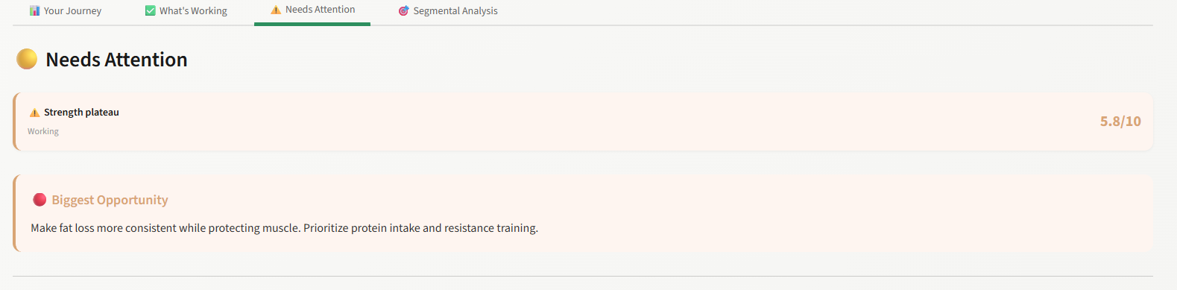
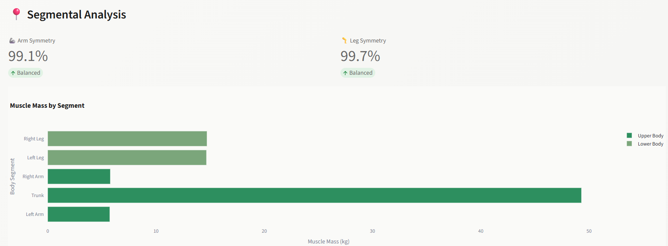
Prompts:
Prompts used to build app is below. First two iterations were just to test how good the output is when the prompt is supplied to LLM. Third prompt was created using “Eat your own dog food method” , use prompt 2 and ask LLM to create a detailed prompt that can be used to build the app
Iteration 1:
You are an certified health and nutrition coach. You will use your expertise knowledge to analyze Inbody Body Composition Analysis data and provide results. Analysis should include What's working, What needs improvement and What's not working. Provide result as a user friendly score card
Iteration 2:
User profile is Male, 44 years, 5 feet 6 inches, 154 lb weight. Exercise frequency is 45 mins of strength training, 3 times a week. Based on your analysis, Create a Scorecard for Muscle Symmetry, Strength Training, Weight, Total Fat, Visceral Fat, Trunk/Abdominal Fat, Overall Trajectory. Use Excellent, Good, Working, Area to Improve, Needs to come down as result set. Sample score card is below. Result should not include any medical diagnosis or advise.

Muscle: 🟢 Good
Muscle symmetry: 🟢 Excellent
Strength training: 🟢 Working
Weight: 🟢 Moving slowly in the right direction
Total fat: 🟠 Main area to improve
Visceral fat: 🟠 Needs to come down
Trunk/abdominal fat: 🟠 Primary focus
Overall trajectory: 🟢 Good foundation, needs a more deliberate fat-loss phase
Iteration 3:
You are an certified health and nutrition coach. Build AI powered app to analyze Body Composition Analysis data and provide results. Streamlit is application of choice. Use Uv for packaging. App should run as localhost for anyone who can invoke the app.App should visually communicate a story within 5 seconds of opening the page.

Input Design:
- User will enter Age (Minimum 18, Maxmimum70), Gender (M/F/NA), Height (Feet & Inches),
Weight in pound or kilogram. Include a label and text box for each input. Include basic validations for each field entered by user.
- User will upload Inbody composition analysis values as csv file. Composition analysis will include below categories as rows and values across time period in columns.
Weight
Skeletal Muscle Mass
Percent Body Fat
ECW/TBW
Body Fat Mass
Left Arm
Right Arm
Trunk
Right Leg
Left Leg
- Minimum of 3 time period of data is required for analysis

Application Guideline
Analysis should include What's working, What needs improvement and What's not working. Provide result as a user friendly score card for Muscle Symmetry, Strength Training, Weight, Total Fat, Visceral Fat, Trunk/Abdominal Fat, Overall Trajectory. Use Excellent, Good, Working, Area to Improve, Needs to come down as result set. Sample score card is below. Result should not include any medical diagnosis or advise. Use 4 tabs or sections as appropriate to present this result. It should be easy to navigate between different result sections

Muscle: 🟢 Good
Muscle symmetry: 🟢 Excellent
Strength training: 🟢 Working
Weight: 🟢 Moving slowly in the right direction
Total fat: 🟠 Main area to improve
Visceral fat: 🟠 Needs to come down
Trunk/abdominal fat: 🟠 Primary focus
Overall trajectory: 🟢 Good foundation, needs a more deliberate fat-loss phase

User Interface Guideline
Style: Modern premium wellness app
Background: Off-white / very light gray
Primary: Deep charcoal/navy
Positive: Sage/emerald green
Attention: Warm amber
Opportunity: Muted coral rather than aggressive red
Cards: Rounded 16–20px corners
Charts: Minimal gridlines, lots of whitespace
Typography: Large numbers, short labels, concise coaching language
Design as Apple Health + Oura + modern personal-training dashboard style, rather than a traditional medical report
Dar / Light mode toggle.

Overall Structure
┌──────────────────────────────────────────┐
│ YOUR BODY COMPOSITION │
│ Progress Dashboard │
│ │
│ ⭐ 8.0 / 10 │
│ Good progress — keep going │
└──────────────────────────────────────────┘

┌──────────┐ ┌──────────┐ ┌──────────┐ ┌──────────┐
│ 153.9 lb │ │ 55.8 lb │ │ 34.3% │ │ 0.378 │
│ ↓ 3.4 lb │ │ ↑ 0.9 lb │ │ ↓ 1.4pt │ │ ↓ 0.011 │
└──────────┘ └──────────┘ └──────────┘ └──────────┘

YOUR BIGGEST WIN
↓ 3.4 lb weight
↑ 0.9 lb muscle

────────────────────────────────────────────

YOUR JOURNEY

[ Weight Chart ]

[ Muscle Chart ]

[ Body Fat Chart ]

────────────────────────────────────────────

🟢 WHAT'S WORKING
Muscle 9/10
Weight 9/10
Hydration 9/10

🟡 NEEDS ATTENTION
Fat loss 6/10
Plateau 7/10
Symmetry 7/10

────────────────────────────────────────────

🔴 BIGGEST OPPORTUNITY

Make fat loss more consistent
while protecting muscle.

────────────────────────────────────────────

SEGMENTAL ANALYSIS

[Body Silhouette]
← arms | trunk | legs →

────────────────────────────────────────────

COACH'S TAKE

"You're doing more right than wrong."

────────────────────────────────────────────

NEXT 90 DAYS

🥩 Protein 🏋️ Strength
🚶 Movement 🔥 Nutrition
📊 Tracking

[View My Goals]

────────────────────────────────────────────

MEASUREMENT HISTORY

Aug 2025 | Oct | Dec | Feb
Apr 2026 | Jun | Aug

